**Kademlia DHT implementation :**

Hello,

For this homework, I wrote my own implementation of Kademlia DHT in Rust language. I used the **kademlia-dht** library available at this address: <https://crates.io/crates/kademlia-dht>

**How to install?**

If you use Windows on a 64 bits platform, you can just download the executable here: <https://github.com/thomasarmel/simple_kademlia_implementation/releases/tag/v1>

Otherwise, run the following commands:

*git clone* [*https://github.com/thomasarmel/simple_kademlia_implementation.git*](https://github.com/thomasarmel/simple_kademlia_implementation.git)

*cd simple_kademlia_implementation*

*cargo build –release*

**How to use it?**

At first, run the first node:

*.\target\release\kademlia.exe -l 127.0.0.1:8080*

In case you want to listen on local interface on port 8080.

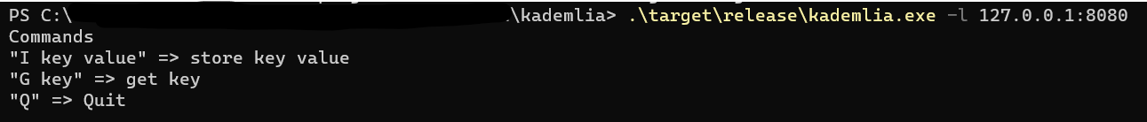

Then another node can join using the first as entry point:

.\target\release\kademlia.exe -l 127.0.0.1:8081 -r 127.0.0.1:8080

It will listen on local interface, on port 8081

Finally, a third node can join using the second one as entry point:

.\target\release\kademlia.exe -l 127.0.0.1:8082 -r 127.0.0.1:8081

It will listen on local interface, on port 8082

**Commands:**

*I my_key my_value* => store **my_value** using key **my_key**.

G my_key => Read value stored with key **my_key**.

*Q* => Quit.

**Example:**

Create first node and insert **key1 => value1**:

Create second node, insert **key2 => value2** and read **key1**:

Create third node, insert **key3 => value3** and read **key1** and **key2**:

On first node, read **key2** and **key3**:

If we modify a value on a node:



Then it will be modified for all nodes:

**How it works?**

**Hashing**

Each node will have an unique identifier, **sha256(ip:port):**



When a node wants to join an existing DHT, it needs to know the entry point and the entry point ID:

The same hashing algorithm is using for the keys.

Here the insertion:



And the reading:

**XOR distance**

Here you can see the closest node is calculated using the XOR distance:

**Buckets:**

We can see buckets work using the node hash as identifier.

**Find a value:**

If the value is stored on local node, return it. Otherwise, find the closest node for the value in the routing table.

And then ask this node for the value.